
МИНОБРНАУКИ РОССИИ
Федеральное государственное бюджетное образовательное учреждение
высшего образования
«МИРЭА − Российский технологический университет»
РТУ МИРЭА
Институт информационных технологий (ИИТ)
Кафедра прикладной математики (ПМ)

ОТЧЕТ ПО ПРАКТИЧЕСКОЙ РАБОТЕ
по дисциплине «Технологии и инструментарий анализа больших данных»

Практическая работа № 5

Студент группы ИНБО-01-17 | ИКБО-50-23, Враженко Д.О. | (подпись)
Проверил | Старший преподаватель,  Воронцов Ю.А. | (подпись)
Отчет представлен | «___»________2026 г.

Москва 2026 г.

Чтение и контроль исходных данных

Импорты и рабочие каталоги
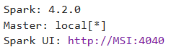

Устойчивый row_id для интернет-сессий

-

Явные схемы и чтение CSV
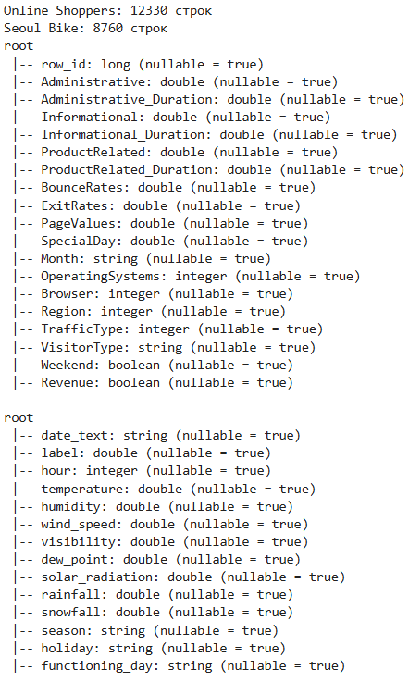

Контроль строк, ключей и пропусков
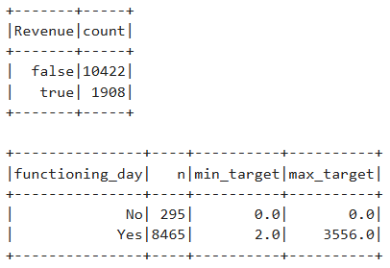

Классификация покупательского намерения

Постановка и дисбаланс классов

-

Момент доступности признаков
-

Преобразование, разбиение и веса классов
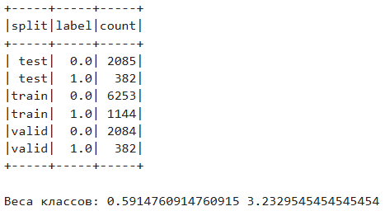

Логистическая регрессия и случайный лес
-

Pipeline двух классификаторов
-

Метрики и обучение

Выбор порога и однократный test

Кривые качества
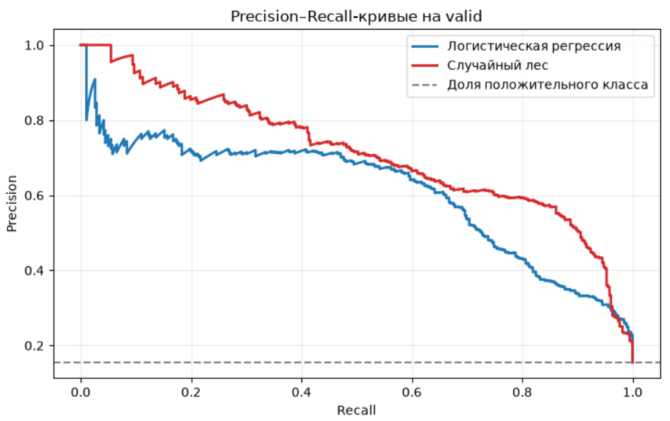
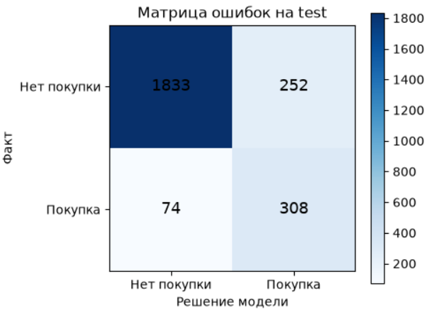

Важность признаков и абляция PageValues
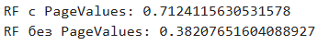

Регрессия спроса Seoul Bike

Постановка задачи
-

Временные признаки и части выборки
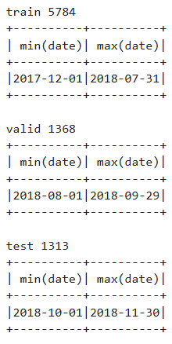

Три регрессионных решения
-

Pipeline регрессоров
-

Метрики и базовые правила
-

Обучение и сравнение
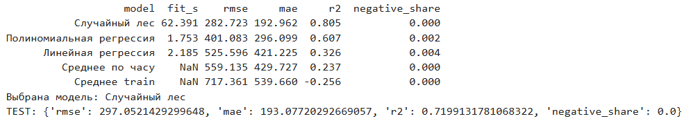

Проверка итоговой модели
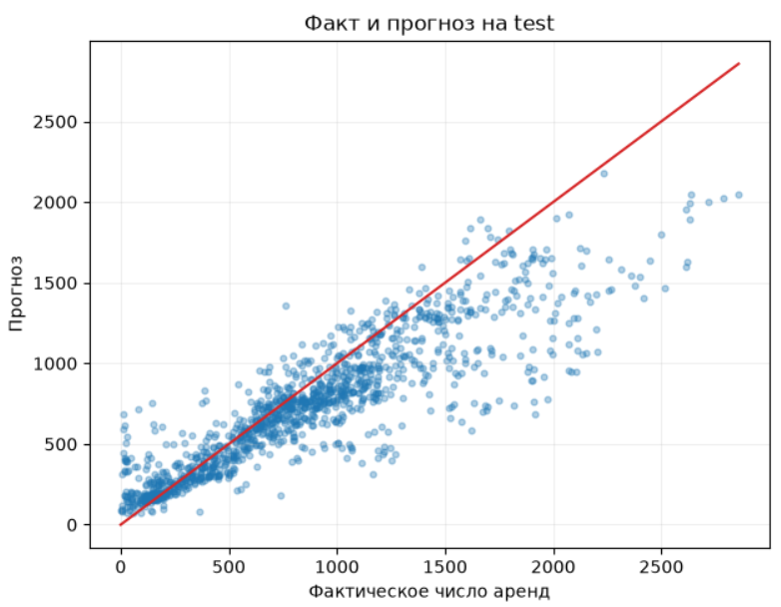
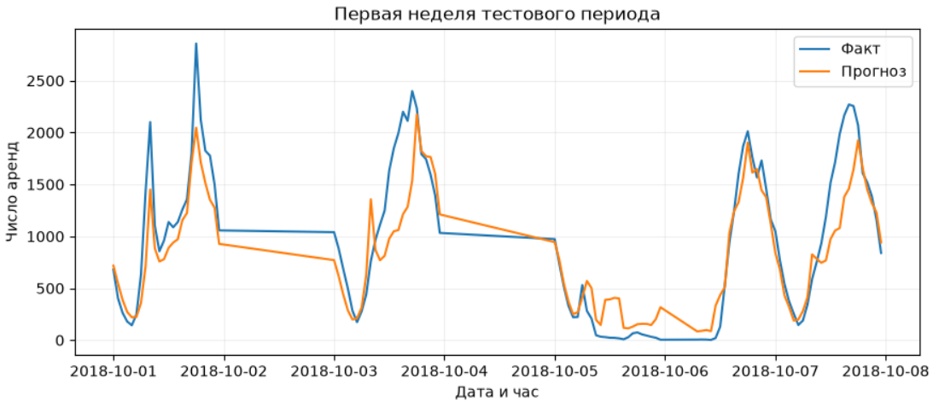

Важность признаков и ограничения
-

Кластеризация интернет-сессий

Смысл задачи
-

Подготовка вектора

KMeans и выбор k
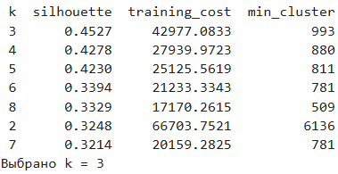

Профили и двумерная проекция
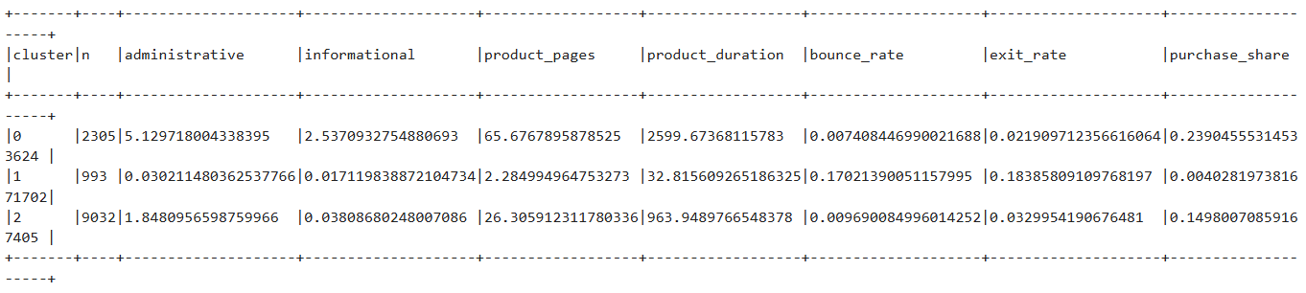
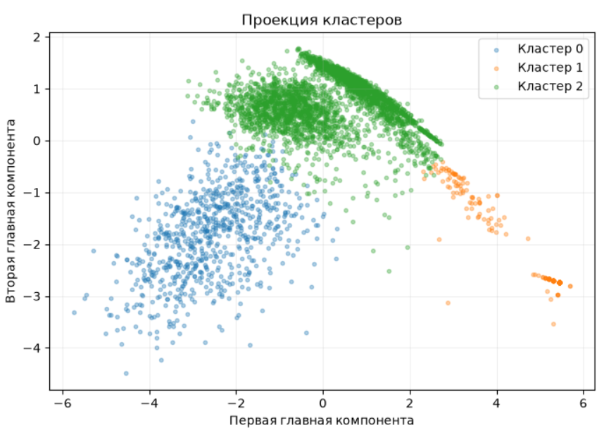

Сохранение и повторное применение моделей

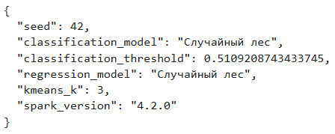

Освобождение кэша

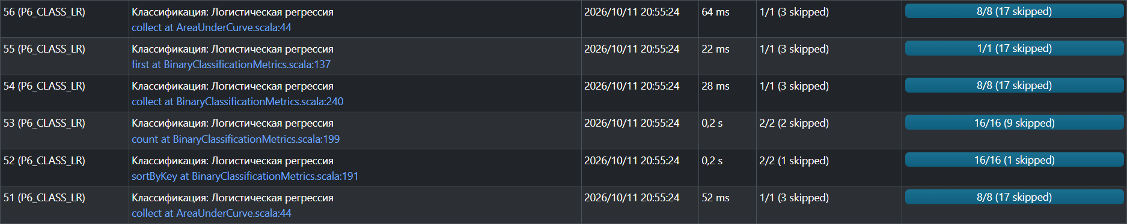
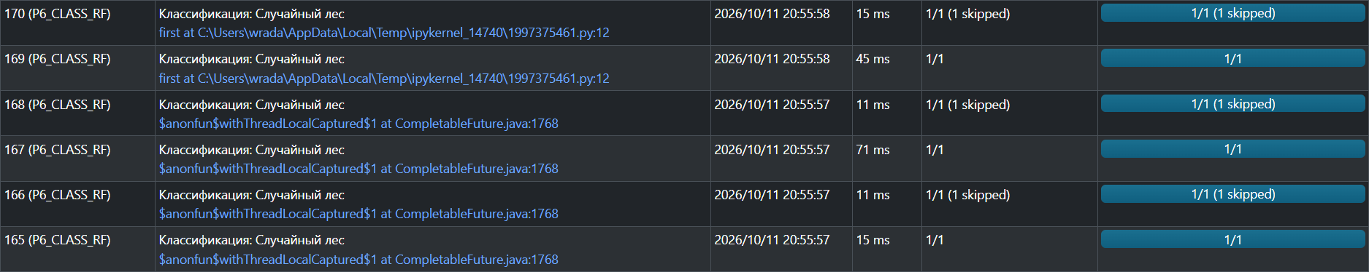
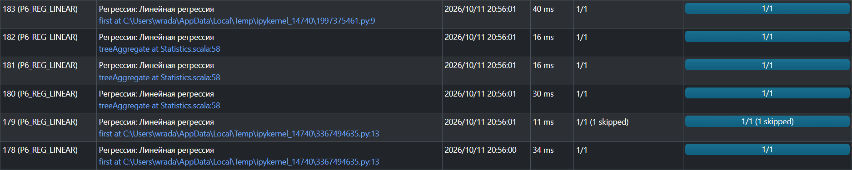




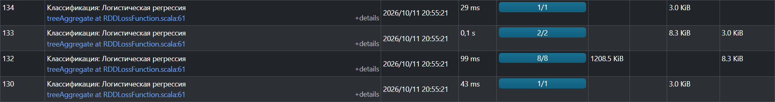
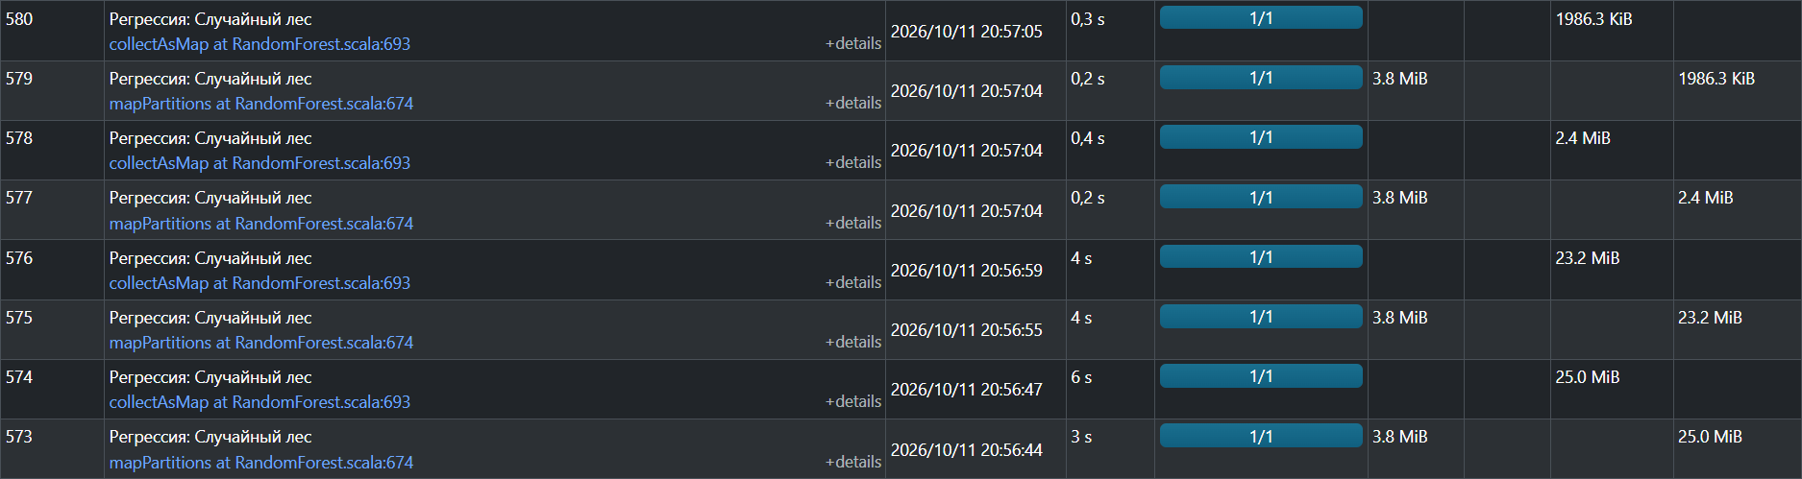
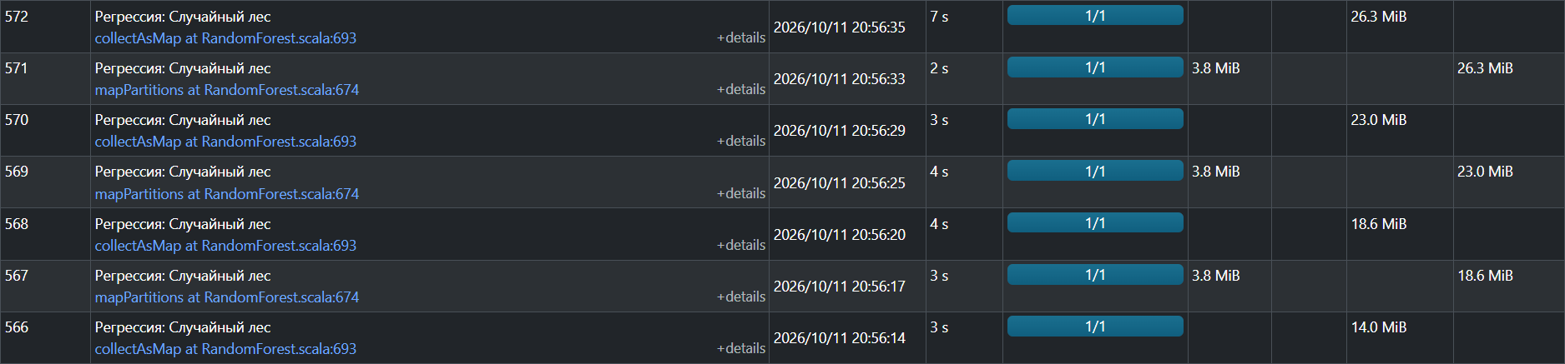

Самостоятельная работа
В качестве самостоятельной работы будет решена задача классификации на основе Spark MLlib с использованием двух моделей машинного обучения. Выбран датасет Airline Satisfaction Data.csv.
from pathlib import Path
from time import perf_counter
import csv
import json
import math
import numpy as np
import pandas as pd
import matplotlib.pyplot as plt
from pyspark.sql import SparkSession, functions as F, Window
from pyspark.sql.types import StructType, StructField, LongType, IntegerType, DoubleType, StringType, BooleanType
from pyspark.ml import Pipeline, PipelineModel
from pyspark.ml.functions import vector_to_array
from pyspark.ml.feature import SQLTransformer, StringIndexer, OneHotEncoder, VectorAssembler, StandardScaler
from pyspark.ml.classification import LogisticRegression, RandomForestClassifier
from pyspark.ml.evaluation import BinaryClassificationEvaluator
from sklearn.metrics import precision_recall_curve, roc_curve, confusion_matrix
spark = (SparkSession.builder
.master("local[*]")
.config("spark.driver.memory", "4g")
.config("spark.sql.shuffle.partitions", "8")
.getOrCreate())
sc = spark.sparkContext
sc.setLogLevel("WARN")
SEED = 42
ROOT = Path.cwd()
WORK = ROOT / "part2_data"
OUT = ROOT / "part2_results"
WORK.mkdir(exist_ok=True)
OUT.mkdir(exist_ok=True)
print("Spark:", spark.version)
print("Master:", sc.master)
print("Spark UI:", sc.uiWebUrl)
Spark: 4.2.0
Master: local[*]
Spark UI: http://MSI:4040
AIR_SOURCE = ROOT / "Airline Satisfaction Data.csv"
if not AIR_SOURCE.is_file():
raise FileNotFoundError(f"Не найден файл: {AIR_SOURCE}")
print("Источник данных:", AIR_SOURCE)
print("Размер:", AIR_SOURCE.stat().st_size // 1024, "KB")
Источник данных: C:\Additional\VirtualMachines\prac5\Airline Satisfaction Data.csv
Размер: 11403 KB

1. Загрузка данных в среду выполнения и определение Spark-схемы
AIR_WORK = WORK / "airline_with_id.csv"
if not AIR_WORK.exists():
with AIR_SOURCE.open("r", encoding="utf-8", newline="") as src, \
AIR_WORK.open("w", encoding="utf-8", newline="") as dst:
reader = csv.reader(src)
writer = csv.writer(dst)
header = next(reader)
writer.writerow(["row_id"] + header)
last_id = 0
for row_id, row in enumerate(reader, start=1):
writer.writerow([row_id] + row)
last_id = row_id
print(f"Добавлен row_id, записано строк: {last_id}")
else:
print("Файл уже существует:", AIR_WORK)
Добавлен row_id, записано строк: 129880
air_schema = StructType([
StructField("row_id", LongType(), False),
# Категориальные
StructField("Gender", StringType(), False),
StructField("Customer Type", StringType(), False),
# Числовые
StructField("Age", IntegerType(), False),
StructField("Type of Travel", StringType(), False),
StructField("Class", StringType(), False),
StructField("Flight Distance", IntegerType(), False),
# Оценки сервиса (1–5, 0 = не оценивалось)
StructField("Inflight wifi service", IntegerType(), False),
StructField("Departure/Arrival time convenient", IntegerType(), False),
StructField("Ease of Online booking", IntegerType(), False),
StructField("Gate location", IntegerType(), False),
StructField("Food and drink", IntegerType(), False),
StructField("Online boarding", IntegerType(), False),
StructField("Seat comfort", IntegerType(), False),
StructField("Inflight entertainment", IntegerType(), False),
StructField("On-board service", IntegerType(), False),
StructField("Leg room service", IntegerType(), False),
StructField("Baggage handling", IntegerType(), False),
StructField("Checkin service", IntegerType(), False),
StructField("Cleanliness", IntegerType(), False),
# Задержки в минутах
StructField("Departure Delay in Minutes", IntegerType(), False),
StructField("Arrival Delay in Minutes", DoubleType(), True),
# Целевая переменная
StructField("satisfaction", BooleanType(), False),
])
air_raw = (spark.read
.option("header", True)
.option("mode", "FAILFAST")
.option("encoding", "utf-8")
.schema(air_schema)
.csv(AIR_WORK.resolve().as_posix())
)
print("Строк:", air_raw.count())
Строк: 129880
air_raw.printSchema()
print("\nЧисло строк:", air_raw.count())
print("Число колонок:", len(air_raw.columns))
air_raw.select("row_id", "Age", "Class", "satisfaction").show(5)
root
|-- row_id: long (nullable = true)
|-- Gender: string (nullable = true)
|-- Customer Type: string (nullable = true)
|-- Age: integer (nullable = true)
|-- Type of Travel: string (nullable = true)
|-- Class: string (nullable = true)
|-- Flight Distance: integer (nullable = true)
|-- Inflight wifi service: integer (nullable = true)
|-- Departure/Arrival time convenient: integer (nullable = true)
|-- Ease of Online booking: integer (nullable = true)
|-- Gate location: integer (nullable = true)
|-- Food and drink: integer (nullable = true)
|-- Online boarding: integer (nullable = true)
|-- Seat comfort: integer (nullable = true)
|-- Inflight entertainment: integer (nullable = true)
|-- On-board service: integer (nullable = true)
|-- Leg room service: integer (nullable = true)
|-- Baggage handling: integer (nullable = true)
|-- Checkin service: integer (nullable = true)
|-- Cleanliness: integer (nullable = true)
|-- Departure Delay in Minutes: integer (nullable = true)
|-- Arrival Delay in Minutes: double (nullable = true)
|-- satisfaction: boolean (nullable = true)
Число строк: 129880
Число колонок: 23
+------+---+--------+------------+
|row_id|Age| Class|satisfaction|
+------+---+--------+------------+
| 1| 13|Eco Plus| false|
| 2| 25|Business| false|
| 3| 26|Business| true|
| 4| 25|Business| false|
| 5| 61|Business| true|
+------+---+--------+------------+
only showing top 5 rows
def null_counts(df):
return df.select(*[
F.sum(F.col(c).isNull().cast("int")).alias(c) for c in df.columns
]).first().asDict()
counts = null_counts(air_raw)
total = air_raw.count()
non_zero = {c: v for c, v in counts.items() if v > 0}
if not non_zero:
print("Пропусков нет ни в одной колонке.")
else:
print("Столбцы с пропусками:")
for c, v in non_zero.items():
print(f" {c}: {v} ({v / total:.2%})")
Столбцы с пропусками:
Arrival Delay in Minutes: 393 (0.30%)
target_dist = (air_raw
.groupBy("satisfaction")
.count()
.orderBy("satisfaction")
.toPandas())
target_dist["share"] = target_dist["count"] / target_dist["count"].sum()
print(target_dist.to_string(index=False))
satisfaction count share
False 73452 0.565537
True 56428 0.434463

2. Просмотр распределения ключей объектов для определения схемы разбиения выборки
KEY_CANDIDATES = ["Gender", "Customer Type", "Type of Travel", "Class"]
total = air_raw.count()
for col in KEY_CANDIDATES:
print(f"\n{col}")
(air_raw.groupBy(col)
.count()
.withColumn("share", F.round(F.col("count") / F.lit(total), 4))
.orderBy(F.desc("count"))
.show(truncate=False))
Gender
+------+-----+------+
|Gender|count|share |
+------+-----+------+
|Female|65899|0.5074|
|Male |63981|0.4926|
+------+-----+------+
Customer Type
+-----------------+------+------+
|Customer Type |count |share |
+-----------------+------+------+
|Loyal Customer |106100|0.8169|
|disloyal Customer|23780 |0.1831|
+-----------------+------+------+
Type of Travel
+---------------+-----+------+
|Type of Travel |count|share |
+---------------+-----+------+
|Business travel|89693|0.6906|
|Personal Travel|40187|0.3094|
+---------------+-----+------+
Class
+--------+-----+------+
|Class |count|share |
+--------+-----+------+
|Business|62160|0.4786|
|Eco |58309|0.4489|
|Eco Plus|9411 |0.0725|
+--------+-----+------+
import time
feature_cols = [c for c in air_raw.columns
if c not in ("row_id", "satisfaction")]
t0 = time.perf_counter()
dups_count = (air_raw
.groupBy(*feature_cols)
.count()
.filter(F.col("count") > 1)
.agg(F.sum("count").alias("duplicated_rows"),
F.count("*").alias("groups_with_dups"))
.first())
dt = time.perf_counter() - t0
print(f"Групп с дубликатами признаков: {dups_count['groups_with_dups']}")
print(f"Строк, входящих в такие группы: {dups_count['duplicated_rows']}")
print(f"Время: {dt:.1f} с")
Групп с дубликатами признаков: 0
Строк, входящих в такие группы: None
Время: 1.7 с
def crosstab_with_target(df, col):
total = df.count()
result = (df.groupBy(col)
.agg(
F.count("*").alias("n"),
F.sum(F.col("satisfaction").cast("int")).alias("satisfied"),
)
.withColumn("share_total", F.round(F.col("n") / F.lit(total), 4))
.withColumn("satisfaction_rate",
F.round(F.col("satisfied") / F.col("n"), 4))
.orderBy(F.desc("satisfaction_rate")))
print(f"\n{col} × satisfaction")
result.show(truncate=False)
for col in KEY_CANDIDATES:
crosstab_with_target(air_raw, col)
Gender × satisfaction
+------+-----+---------+-----------+-----------------+
|Gender|n |satisfied|share_total|satisfaction_rate|
+------+-----+---------+-----------+-----------------+
|Male |63981|28159 |0.4926 |0.4401 |
|Female|65899|28269 |0.5074 |0.429 |
+------+-----+---------+-----------+-----------------+
Customer Type × satisfaction
+-----------------+------+---------+-----------+-----------------+
|Customer Type |n |satisfied|share_total|satisfaction_rate|
+-----------------+------+---------+-----------+-----------------+
|Loyal Customer |106100|50728 |0.8169 |0.4781 |
|disloyal Customer|23780 |5700 |0.1831 |0.2397 |
+-----------------+------+---------+-----------+-----------------+
Type of Travel × satisfaction
+---------------+-----+---------+-----------+-----------------+
|Type of Travel |n |satisfied|share_total|satisfaction_rate|
+---------------+-----+---------+-----------+-----------------+
|Business travel|89693|52356 |0.6906 |0.5837 |
|Personal Travel|40187|4072 |0.3094 |0.1013 |
+---------------+-----+---------+-----------+-----------------+
Class × satisfaction
+--------+-----+---------+-----------+-----------------+
|Class |n |satisfied|share_total|satisfaction_rate|
+--------+-----+---------+-----------+-----------------+
|Business|62160|43166 |0.4786 |0.6944 |
|Eco Plus|9411 |2319 |0.0725 |0.2464 |
|Eco |58309|10943 |0.4489 |0.1877 |
+--------+-----+---------+-----------+-----------------+

3. Разбиение набора данных на тренировочный, валидационный и тестовый наборы, опираясь на смысл выборки (независимые объекты / временные данные).
air = air_raw.withColumn("label", F.col("satisfaction").cast("double"))
print("Распределение label:")
air.groupBy("label").count().orderBy("label").show()
Распределение label:
+-----+-----+
|label|count|
+-----+-----+
| 0.0|73452|
| 1.0|56428|
+-----+-----+
order_key = F.sha2(
F.concat_ws(":", F.col("row_id").cast("string"), F.lit(str(SEED))),
256
)
rank_window = Window.partitionBy("label").orderBy(order_key, "row_id")
class_window = Window.partitionBy("label")
air_split = (air
.withColumn("_rank", F.row_number().over(rank_window))
.withColumn("_size", F.count("*").over(class_window))
.withColumn("split",
F.when(F.col("_rank") <= F.floor(F.col("_size") * 0.60), "train")
.when(F.col("_rank") <= F.floor(F.col("_size") * 0.80), "valid")
.otherwise("test"))
.drop("_rank", "_size")
.cache())
air_split.groupBy("split", "label").count().orderBy("split", "label").show()
+-----+-----+-----+
|split|label|count|
+-----+-----+-----+
| test| 0.0|14691|
| test| 1.0|11286|
|train| 0.0|44071|
|train| 1.0|33856|
|valid| 0.0|14690|
|valid| 1.0|11286|
+-----+-----+-----+
air_train = air_split.filter("split = 'train'").drop("split").cache()
air_valid = air_split.filter("split = 'valid'").drop("split").cache()
air_test = air_split.filter("split = 'test'").drop("split").cache()
n_train = air_train.count()
n_valid = air_valid.count()
n_test = air_test.count()
n_total = n_train + n_valid + n_test
print(f"train: {n_train:>7} ({n_train/n_total:.2%})")
print(f"valid: {n_valid:>7} ({n_valid/n_total:.2%})")
print(f"test: {n_test:>7} ({n_test/n_total:.2%})")
print(f"итого: {n_total:>7}")
train: 77927 (60.00%)
valid: 25976 (20.00%)
test: 25977 (20.00%)
итого: 129880
assert n_total == 129880, f"Потеря строк: {n_total} != 129880"
print("OK: сумма частей равна исходному размеру")
OK: сумма частей равна исходному размеру
train_ids = set(r["row_id"] for r in air_train.select("row_id").collect())
valid_ids = set(r["row_id"] for r in air_valid.select("row_id").collect())
test_ids = set(r["row_id"] for r in air_test.select("row_id").collect())
inter_tv = len(train_ids & valid_ids)
inter_tt = len(train_ids & test_ids)
inter_vt = len(valid_ids & test_ids)
print(f"Пересечения row_id: train∩valid={inter_tv}, train∩test={inter_tt}, valid∩test={inter_vt}")
assert inter_tv == 0 and inter_tt == 0 and inter_vt == 0, "Пересечение частей!"
print("OK: пересечений нет")
Пересечения row_id: train∩valid=0, train∩test=0, valid∩test=0
OK: пересечений нет
share_orig = (air.select(F.avg("label")).first()[0])
for name, df in [("train", air_train), ("valid", air_valid), ("test", air_test)]:
n = df.count()
pos = df.filter(F.col("label") == 1.0).count()
print(f"{name:5s} Positive share = {pos/n:.4f} (исходное: {share_orig:.4f})")
train Positive share = 0.4345 (исходное: 0.4345)
valid Positive share = 0.4345 (исходное: 0.4345)
test Positive share = 0.4345 (исходное: 0.4345)
print("Колонки train:", air_train.columns)
print("Тип label:", air_train.schema["label"].dataType)
print("Тип satisfaction:", air_train.schema["satisfaction"].dataType)
Колонки train: ['row_id', 'Gender', 'Customer Type', 'Age', 'Type of Travel', 'Class', 'Flight Distance', 'Inflight wifi service', 'Departure/Arrival time convenient', 'Ease of Online booking', 'Gate location', 'Food and drink', 'Online boarding', 'Seat comfort', 'Inflight entertainment', 'On-board service', 'Leg room service', 'Baggage handling', 'Checkin service', 'Cleanliness', 'Departure Delay in Minutes', 'Arrival Delay in Minutes', 'satisfaction', 'label']
Тип label: DoubleType()
Тип satisfaction: BooleanType()

4. Просмотр распределений предикторов и целевой переменной
NUMERIC_COLS = ["Age", "Flight Distance", "Departure Delay in Minutes", "Arrival Delay in Minutes"]
air_train.select(*NUMERIC_COLS).describe().show(truncate=False)
+-------+------------------+------------------+--------------------------+------------------------+
|summary|Age |Flight Distance |Departure Delay in Minutes|Arrival Delay in Minutes|
+-------+------------------+------------------+--------------------------+------------------------+
|count |77927 |77927 |77927 |77690 |
|mean |39.39861665404802 |1191.4255906168594|14.614036213379189 |15.019050070794181 |
|stddev |15.113112334965617|996.5786305761392 |37.63648082170992 |38.00817101028292 |
|min |7 |31 |0 |0.0 |
|max |85 |4983 |1592 |1584.0 |
+-------+------------------+------------------+--------------------------+------------------------+
local_num = air_train.select("Age", "Flight Distance", "Departure Delay in Minutes", "Arrival Delay in Minutes", "label").toPandas()
fig, axes = plt.subplots(2, 2, figsize=(12, 8))
axes[0, 0].hist(local_num["Age"], bins=40, color="tab:blue", edgecolor="white")
axes[0, 0].set_title("Age")
axes[0, 0].set_xlabel("Возраст (лет)")
axes[0, 1].hist(local_num["Flight Distance"], bins=50, color="tab:green", edgecolor="white")
axes[0, 1].set_title("Flight Distance")
axes[0, 1].set_xlabel("Дистанция (мили)")
axes[0, 1].set_yscale("log")
d = local_num["Departure Delay in Minutes"]
axes[1, 0].hist(d[d <= 200], bins=50, color="tab:orange", edgecolor="white")
axes[1, 0].set_title("Departure Delay in Minutes (обрезано до 200)")
axes[1, 0].set_xlabel("Минуты")
d = local_num["Arrival Delay in Minutes"].dropna()
axes[1, 1].hist(d[d <= 200], bins=50, color="tab:red", edgecolor="white")
axes[1, 1].set_title("Arrival Delay in Minutes (обрезано до 200)")
axes[1, 1].set_xlabel("Минуты")
plt.tight_layout()
plt.savefig(OUT / "numeric_distributions.png", dpi=160)
plt.show()
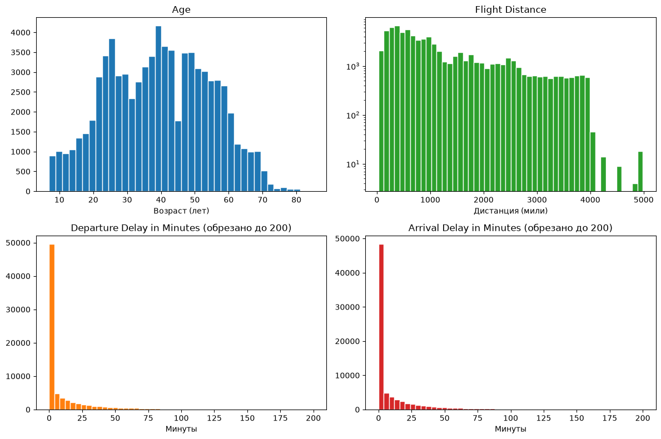
fig, axes = plt.subplots(2, 2, figsize=(12, 8))
for ax, col in zip(axes.flat, ["Age", "Flight Distance", "Departure Delay in Minutes", "Arrival Delay in Minutes"]):
values_neg = local_num.loc[local_num["label"] == 0.0, col].dropna()
values_pos = local_num.loc[local_num["label"] == 1.0, col].dropna()
if "Delay" in col:
values_neg = values_neg[values_neg <= 200]
values_pos = values_pos[values_pos <= 200]
ax.hist(values_neg, bins=40, alpha=0.55, label="Not Satisfied",
color="tab:blue", density=True)
ax.hist(values_pos, bins=40, alpha=0.55, label="Satisfied",
color="tab:red", density=True)
ax.set_title(col)
ax.legend()
plt.tight_layout()
plt.savefig(OUT / "numeric_distributions_by_class.png", dpi=160)
plt.show()
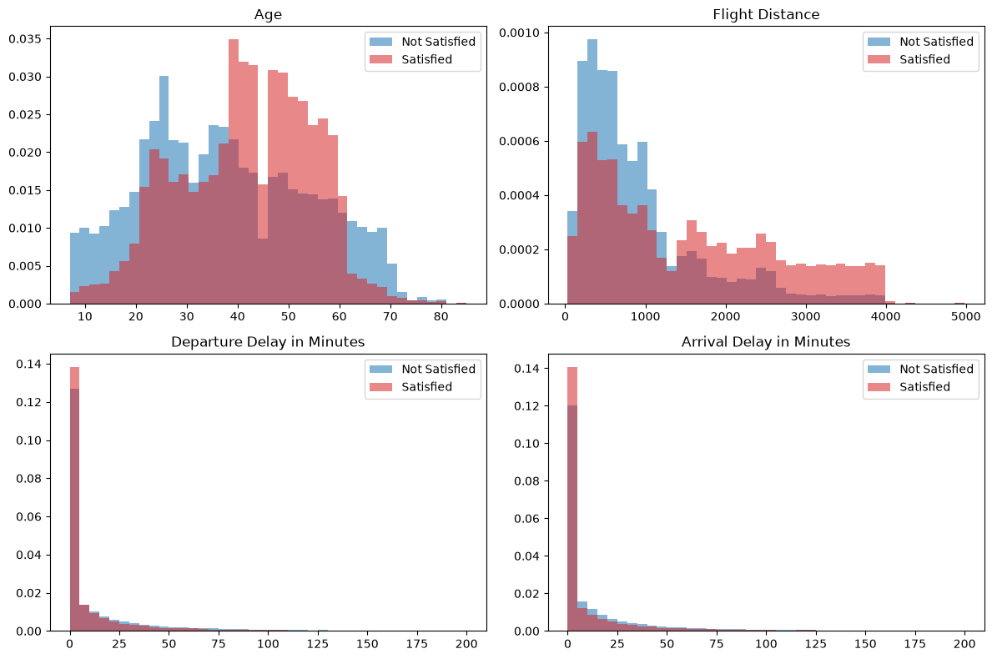
RATING_COLS = ["Inflight wifi service", "Departure/Arrival time convenient", "Ease of Online booking",
"Gate location", "Food and drink", "Online boarding", "Seat comfort", "Inflight entertainment",
"On-board service", "Leg room service", "Baggage handling", "Checkin service", "Cleanliness"
]
summary = (air_train
.groupBy("label")
.agg(*[F.round(F.avg(c), 3).alias(c) for c in RATING_COLS])
.orderBy("label")
.toPandas()
.set_index("label"))
print("Средние оценки по классам:")
print(summary.T.to_string())
Средние оценки по классам:
label 0.0 1.0
Inflight wifi service 2.403 3.163
Departure/Arrival time convenient 3.140 2.970
Ease of Online booking 2.553 3.035
Gate location 2.988 2.973
Food and drink 2.959 3.517
Online boarding 2.661 4.024
Seat comfort 3.041 3.966
Inflight entertainment 2.891 3.966
On-board service 3.020 3.866
Leg room service 2.990 3.830
Baggage handling 3.375 3.968
Checkin service 3.049 3.650
Cleanliness 2.932 3.742
local_ratings = air_train.select(*RATING_COLS).toPandas()
fig, axes = plt.subplots(3, 5, figsize=(16, 9))
for ax, col in zip(axes.flat, RATING_COLS):
counts = local_ratings[col].value_counts().sort_index()
ax.bar(counts.index, counts.values, color="tab:blue", edgecolor="white")
ax.set_title(col, fontsize=9)
ax.set_xticks([0, 1, 2, 3, 4, 5])
axes.flat[-1].axis("off")
axes.flat[-2].axis("off")
plt.tight_layout()
plt.savefig(OUT / "rating_distributions.png", dpi=160)
plt.show()
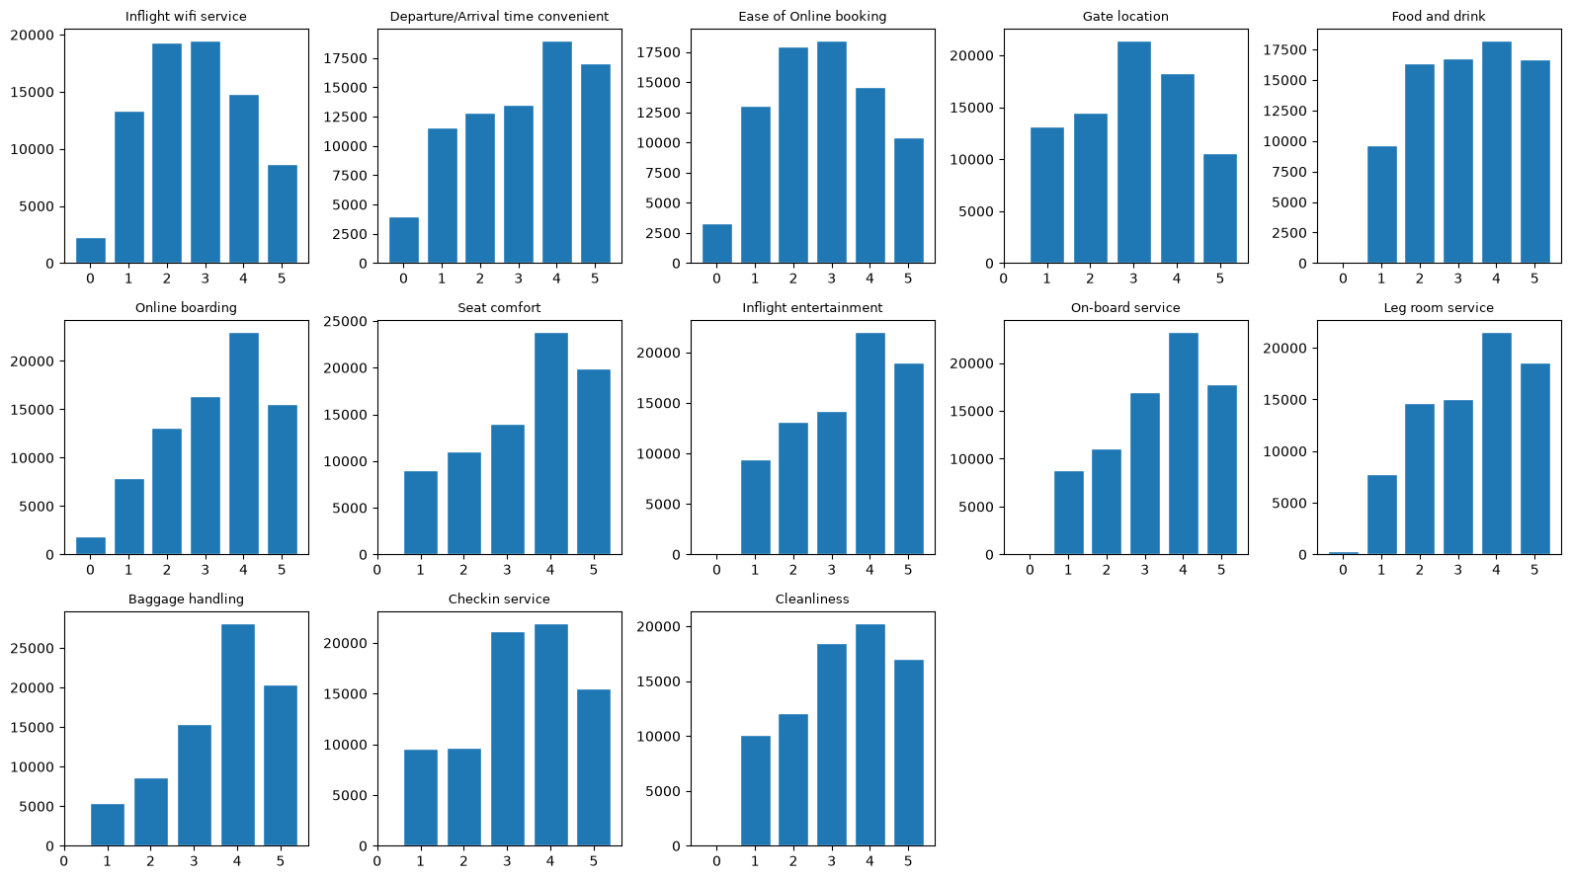
def stats_by_label(df, col):
return (df.groupBy("label")
.agg(F.round(F.avg(col), 2).alias("mean"),
F.round(F.expr(f"percentile_approx(`{col}`, 0.5)"), 2).alias("median"),
F.round(F.stddev(col), 2).alias("std"))
.orderBy("label")
.toPandas()
.assign(feature=col)
.set_index(["feature", "label"]))
rows = [stats_by_label(air_train, c) for c in NUMERIC_COLS]
print(pd.concat(rows).to_string())
mean median std
feature label
Age 0.0 37.64 36.0 16.45
1.0 41.69 43.0 12.81
Flight Distance 0.0 928.20 674.0 788.48
1.0 1534.07 1265.0 1126.56
Departure Delay in Minutes 0.0 16.29 0.0 40.02
1.0 12.43 0.0 34.16
Arrival Delay in Minutes 0.0 16.99 0.0 40.39
1.0 12.45 0.0 34.50
CORR_COLS = ["Age", "Flight Distance", "Departure Delay in Minutes", "Arrival Delay in Minutes"] + RATING_COLS
local_corr = air_train.select(*CORR_COLS).toPandas()
corr = local_corr.corr(numeric_only=True)
fig, ax = plt.subplots(figsize=(11, 9))
im = ax.imshow(corr, cmap="RdBu_r", vmin=-1, vmax=1)
ax.set_xticks(range(len(corr)))
ax.set_yticks(range(len(corr)))
ax.set_xticklabels(corr.columns, rotation=90, fontsize=8)
ax.set_yticklabels(corr.columns, fontsize=8)
plt.colorbar(im, ax=ax, fraction=0.04)
ax.set_title("Корреляции числовых и порядковых признаков (train)")
plt.tight_layout()
plt.savefig(OUT / "correlation_matrix.png", dpi=160)
plt.show()
import itertools
pairs = [(corr.iloc[i, j], corr.columns[i], corr.columns[j])
for i, j in itertools.combinations(range(len(corr)), 2)]
pairs.sort(reverse=True)
print("Топ-5 положительных корреляций:")
for v, a, b in pairs[:5]:
print(f" {v:+.3f} {a} ↔ {b}")
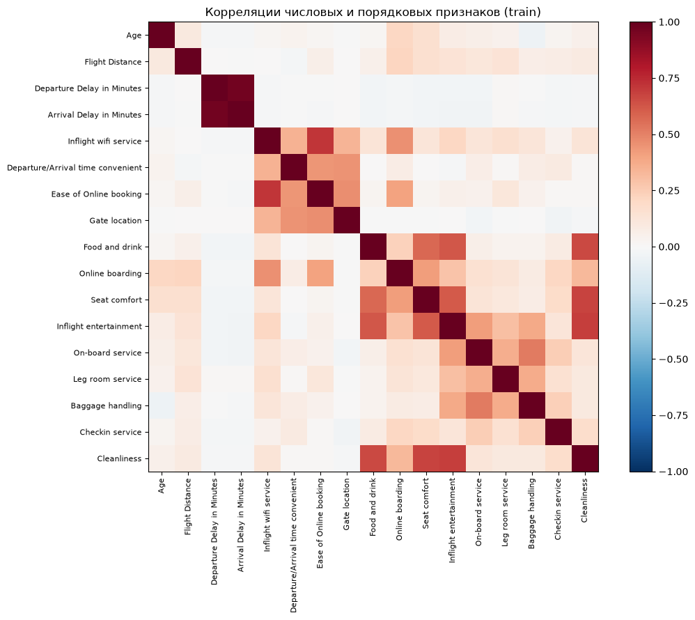
Топ-5 положительных корреляций:
+0.964 Departure Delay in Minutes ↔ Arrival Delay in Minutes
+0.718 Inflight wifi service ↔ Ease of Online booking
+0.694 Inflight entertainment ↔ Cleanliness
+0.677 Seat comfort ↔ Cleanliness
+0.660 Food and drink ↔ Cleanliness

5. Выбор предикторов и целевой переменной прогнозирования, определение точек возможной утечки данных.
CAT_COLS = ["Gender", "Customer Type", "Type of Travel", "Class"]
RATING_COLS = [
"Inflight wifi service",
"Departure/Arrival time convenient",
"Ease of Online booking",
"Gate location",
"Food and drink",
"Online boarding",
"Seat comfort",
"Inflight entertainment",
"On-board service",
"Leg room service",
"Baggage handling",
"Checkin service",
"Cleanliness",
]
NUM_BASE = ["Age", "Flight Distance"]
DELAY_COL = "Departure Delay in Minutes"
LOG_SOURCE = [DELAY_COL]
LOG_OUTPUT = ["log_" + DELAY_COL]
RAW_A = NUM_BASE + [DELAY_COL] + RATING_COLS + CAT_COLS
RAW_B = NUM_BASE + RATING_COLS + CAT_COLS
for name, cols in [("A (с задержкой)", RAW_A), ("B (без задержки)", RAW_B)]:
n_null = air_train.select(*[
F.sum(F.col(c).isNull().cast("int")).alias(c) for c in cols
]).first().asDict()
non_zero = {c: v for c, v in n_null.items() if v > 0}
total_null = sum(non_zero.values())
print(f"Сценарий {name}: {len(cols)} признаков, пропусков = {total_null} ({non_zero if non_zero else 'нет'})")
print("\nУникальные значения label:", sorted(r["label"] for r in air_train.select("label").distinct().collect()))
Сценарий A (с задержкой): 20 признаков, пропусков = 0 (нет)
Сценарий B (без задержки): 19 признаков, пропусков = 0 (нет)
Уникальные значения label: [0.0, 1.0]

6. Построение и оценка параметров моделей машинного обучения, подбор оптимальных гиперпараметров либо с помощью кросс-валидации, либо минимизируя функцию стоимости на валидационной выборке.
from pyspark.ml.evaluation import BinaryClassificationEvaluator
def binary_metrics(pred, threshold=0.5, ranking=True):
decision = F.col("score") >= F.lit(float(threshold))
y = F.col("label") == 1.0
values = pred.agg(
F.sum((decision & y).cast("long")).alias("tp"),
F.sum((decision & ~y).cast("long")).alias("fp"),
F.sum((~decision & y).cast("long")).alias("fn"),
F.sum((~decision & ~y).cast("long")).alias("tn"),
).first().asDict()
tp, fp, fn, tn = values["tp"], values["fp"], values["fn"], values["tn"]
n = tp + fp + fn + tn
precision = tp / (tp + fp) if tp + fp else 0.0
recall = tp / (tp + fn) if tp + fn else 0.0
f1 = 2 * precision * recall / (precision + recall) if precision + recall else 0.0
result = {
"accuracy": (tp + tn) / n,
"precision": precision,
"recall": recall,
"f1": f1,
"tp": tp,
"fp": fp,
"fn": fn,
"tn": tn,
}
if ranking and "score" in pred.columns:
for m in ["areaUnderROC", "areaUnderPR"]:
result[m] = BinaryClassificationEvaluator(
labelCol="label", rawPredictionCol="score",
metricName=m).evaluate(pred)
return result
pos_rate_train = air_train.agg(F.avg("label")).first()[0]
print(f"Доля положительного класса в train: {pos_rate_train:.4f}")
baseline_constant = (air_valid
.withColumn("score", F.lit(float(pos_rate_train)))
.withColumn("prediction", F.lit(0.0)))
print("Baseline «всегда большинство» на valid:")
print(binary_metrics(baseline_constant, threshold=0.5, ranking=True))
Доля положительного класса в train: 0.4345
Baseline «всегда большинство» на valid:
{'accuracy': 0.5655220203264552, 'precision': 0.0, 'recall': 0.0, 'f1': 0.0, 'tp': 0, 'fp': 0, 'fn': 11286, 'tn': 14690, 'areaUnderROC': 0.5, 'areaUnderPR': 0.4344779796735448}
class_rate = (air_train
.groupBy("Class")
.agg(F.avg("label").alias("class_rate"))
.toPandas())
print(class_rate.to_string(index=False))
class_rate_df = spark.createDataFrame(class_rate)
baseline_class = (air_valid
.join(class_rate_df, "Class", "left")
.withColumn("score", F.col("class_rate"))
.withColumn("prediction", (F.col("class_rate") >= 0.5).cast("double"))
.drop("class_rate"))
print("\nBaseline «правило по Class» на valid:")
print(binary_metrics(baseline_class, threshold=0.5, ranking=True))
Class class_rate
Eco Plus 0.252174
Business 0.695556
Eco 0.186627
Baseline «правило по Class» на valid:
{'accuracy': 0.7507314444102248, 'precision': 0.693508165071193, 'recall': 0.763866737550948, 'f1': 0.7269890795631826, 'tp': 8621, 'fp': 3810, 'fn': 2665, 'tn': 10880, 'areaUnderROC': 0.7554567084143238, 'areaUnderPR': 0.6610488260311178}
from pyspark.ml import Pipeline
from pyspark.ml.feature import (
SQLTransformer, StringIndexer, OneHotEncoder,
VectorAssembler, StandardScaler,
)
from pyspark.ml.classification import LogisticRegression
def airline_lr_pipeline(include_delay=True, reg_param=0.05):
if include_delay:
log_stage = SQLTransformer(
statement=f"SELECT *, log1p(`{DELAY_COL}`) AS `{LOG_OUTPUT[0]}` FROM __THIS__"
)
numeric_after_log = NUM_BASE + LOG_OUTPUT + RATING_COLS
stages = [log_stage]
else:
numeric_after_log = NUM_BASE + RATING_COLS
stages = []
idx_cols = [c + "_idx" for c in CAT_COLS]
ohe_cols = [c + "_ohe" for c in CAT_COLS]
indexer = StringIndexer(
inputCols=CAT_COLS, outputCols=idx_cols,
handleInvalid="keep", stringOrderType="alphabetAsc",
)
encoder = OneHotEncoder(
inputCols=idx_cols, outputCols=ohe_cols,
handleInvalid="keep", dropLast=False,
)
assembler = VectorAssembler(
inputCols=numeric_after_log + ohe_cols,
outputCol="features_raw",
)
scaler = StandardScaler(
inputCol="features_raw", outputCol="features",
withMean=False, withStd=True,
)
lr = LogisticRegression(
maxIter=100, regParam=reg_param, elasticNetParam=0.0,
standardization=False,
)
stages += [indexer, encoder, assembler, scaler, lr]
return Pipeline(stages=stages)
from pyspark.ml.classification import RandomForestClassifier
def airline_rf_pipeline(include_delay=True, num_trees=80, max_depth=12):
if include_delay:
numeric = NUM_BASE + [DELAY_COL] + RATING_COLS
else:
numeric = NUM_BASE + RATING_COLS
idx_cols = [c + "_idx" for c in CAT_COLS]
ohe_cols = [c + "_ohe" for c in CAT_COLS]
indexer = StringIndexer(
inputCols=CAT_COLS, outputCols=idx_cols,
handleInvalid="keep", stringOrderType="alphabetAsc",
)
encoder = OneHotEncoder(
inputCols=idx_cols, outputCols=ohe_cols,
handleInvalid="keep", dropLast=False,
)
assembler = VectorAssembler(
inputCols=numeric + ohe_cols,
outputCol="features",
)
rf = RandomForestClassifier(
numTrees=num_trees, maxDepth=max_depth, maxBins=64,
featureSubsetStrategy="sqrt", seed=SEED,
)
return Pipeline(stages=[indexer, encoder, assembler, rf])
def scores(model, df):
return (model.transform(df)
.withColumn("score", vector_to_array("probability")[1])
.select("row_id", "label", "score"))
import time
results = []
models = {}
for reg in [0.01, 0.1]:
name = f"LR(reg={reg})"
sc.setJobGroup("AIR_LR", name)
t0 = time.perf_counter()
model = airline_lr_pipeline(include_delay=True, reg_param=reg).fit(air_train)
fit_s = time.perf_counter() - t0
pred = scores(model, air_valid).cache()
pred.count()
m = binary_metrics(pred)
results.append({"model": name, "fit_s": round(fit_s, 1), **m})
models[name] = (model, pred)
for nt, md in [(50, 8), (100, 12)]:
name = f"RF(trees={nt}, depth={md})"
sc.setJobGroup("AIR_RF", name)
t0 = time.perf_counter()
model = airline_rf_pipeline(include_delay=True, num_trees=nt, max_depth=md).fit(air_train)
fit_s = time.perf_counter() - t0
pred = scores(model, air_valid).cache()
pred.count()
m = binary_metrics(pred)
results.append({"model": name, "fit_s": round(fit_s, 1), **m})
models[name] = (model, pred)
results.append({"model": "Baseline: константа", "fit_s": 0.0, **binary_metrics(baseline_constant)})
results.append({"model": "Baseline: правило по Class", "fit_s": 0.0, **binary_metrics(baseline_class)})
val_table = pd.DataFrame(results).sort_values("areaUnderPR", ascending=False)
cols = ["model", "fit_s", "accuracy", "precision", "recall", "f1", "areaUnderROC", "areaUnderPR"]
print(val_table[cols].round(4).to_string(index=False))
model fit_s accuracy precision recall f1 areaUnderROC areaUnderPR
RF(trees=100, depth=12) 61.7 0.9500 0.9492 0.9350 0.9420 0.9896 0.9884
RF(trees=50, depth=8) 16.0 0.9354 0.9325 0.9177 0.9250 0.9819 0.9785
LR(reg=0.01) 18.8 0.8741 0.8695 0.8356 0.8522 0.9275 0.9306
LR(reg=0.1) 8.2 0.8688 0.8683 0.8228 0.8449 0.9232 0.9265
Baseline: правило по Class 0.0 0.7507 0.6935 0.7639 0.7270 0.7555 0.6610
Baseline: константа 0.0 0.5655 0.0000 0.0000 0.0000 0.5000 0.4345
learned = val_table[~val_table["model"].str.startswith("Baseline")]
best_name = learned.iloc[0]["model"]
best_model, best_pred_valid = models[best_name]
print("Лучшая модель по PR-AUC:", best_name)
print("PR-AUC:", round(learned.iloc[0]["areaUnderPR"], 4))
print("Accuracy:", round(learned.iloc[0]["accuracy"], 4))
Лучшая модель по PR-AUC: RF(trees=100, depth=12)
PR-AUC: 0.9884
Accuracy: 0.95
rf_cfg = best_name.replace("RF(trees=", "").replace(")", "").split(", depth=")
n_trees, depth = int(rf_cfg[0]), int(rf_cfg[1])
rf_no_delay = airline_rf_pipeline(
include_delay=False, num_trees=n_trees, max_depth=depth,
).fit(air_train)
pred_no_delay = scores(rf_no_delay, air_valid).cache()
pred_no_delay.count()
print("RF с задержкой:", binary_metrics(best_pred_valid)["areaUnderPR"])
print("RF без задержки:", binary_metrics(pred_no_delay)["areaUnderPR"])
RF с задержкой: 0.9883693488644335
RF без задержки: 0.9882114066070997

7. Оценка качества модели на тестовых данных с использованием метрики качества модели и визуализация работы модели на тестовой выборке.
from sklearn.metrics import precision_recall_curve
valid_pd = best_pred_valid.toPandas()
precision, recall, thresholds = precision_recall_curve(valid_pd["label"], valid_pd["score"])
f1_scores = 2 * precision * recall / np.maximum(precision + recall, 1e-12)
best_idx = int(np.nanargmax(f1_scores[:-1]))
BEST_THRESHOLD = float(thresholds[best_idx])
print(f"Порог по максимуму F1 на valid: {BEST_THRESHOLD:.4f}")
print(f"F1 при этом пороге: {f1_scores[best_idx]:.4f}")
print(f"Precision при этом пороге: {precision[best_idx]:.4f}")
print(f"Recall при этом пороге: {recall[best_idx]:.4f}")
Порог по максимуму F1 на valid: 0.5515
F1 при этом пороге: 0.9431
Precision при этом пороге: 0.9572
Recall при этом пороге: 0.9295
test_scores = scores(best_model, air_test).cache()
test_scores.count()
print("Метрики на test при пороге из valid:")
test_metrics = binary_metrics(test_scores, threshold=BEST_THRESHOLD)
for k, v in test_metrics.items():
if isinstance(v, float):
print(f" {k} = {v:.4f}")
else:
print(f" {k} = {v}")
Метрики на test при пороге из valid:
accuracy = 0.9553
precision = 0.9599
recall = 0.9362
f1 = 0.9479
tp = 10566
fp = 441
fn = 720
tn = 14250
areaUnderROC = 0.9911
areaUnderPR = 0.9901
compare = []
for name, thr in [("Порог 0.5", 0.5), (f"Порог {BEST_THRESHOLD:.3f}", BEST_THRESHOLD)]:
m = binary_metrics(test_scores, threshold=thr)
compare.append({
"scenario": name,
"accuracy": round(m["accuracy"], 4),
"precision": round(m["precision"], 4),
"recall": round(m["recall"], 4),
"f1": round(m["f1"], 4),
"tp": m["tp"],
"fp": m["fp"],
"fn": m["fn"],
"tn": m["tn"],
})
print(pd.DataFrame(compare).to_string(index=False))
scenario accuracy precision recall f1 tp fp fn tn
Порог 0.5 0.9547 0.9534 0.9417 0.9475 10628 519 658 14172
Порог 0.552 0.9553 0.9599 0.9362 0.9479 10566 441 720 14250
from sklearn.metrics import confusion_matrix
test_pd = test_scores.toPandas()
test_pred = (test_pd["score"] >= BEST_THRESHOLD).astype(int)
cm = confusion_matrix(test_pd["label"].astype(int), test_pred, labels=[0, 1])
fig, ax = plt.subplots(figsize=(5.5, 4.5))
im = ax.imshow(cm, cmap="Blues")
for i in range(2):
for j in range(2):
ax.text(j, i, cm[i, j], ha="center", va="center", fontsize=14, color="white" if cm[i, j] > cm.max() / 2 else "black")
ax.set_xticks([0, 1], ["Not Satisfied", "Satisfied"])
ax.set_yticks([0, 1], ["Not Satisfied", "Satisfied"])
ax.set_xlabel("Прогноз модели")
ax.set_ylabel("Фактический класс")
ax.set_title(f"Матрица ошибок на test (порог {BEST_THRESHOLD:.3f})")
plt.colorbar(im, ax=ax, fraction=0.04)
plt.tight_layout()
plt.savefig(OUT / "test_confusion_matrix.png", dpi=160)
plt.show()
print(f"TP={cm[1,1]} FP={cm[0,1]} FN={cm[1,0]} TN={cm[0,0]}")
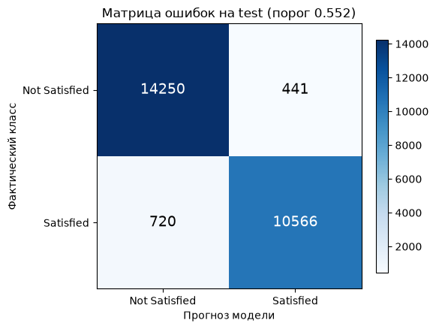
TP=10566 FP=441 FN=720 TN=14250
from sklearn.metrics import roc_curve, auc
fig, axes = plt.subplots(1, 2, figsize=(13, 5))
ax = axes[0]
for label, pdf, color in [
("Valid", valid_pd, "tab:blue"),
("Test", test_pd, "tab:red"),
]:
p, r, _ = precision_recall_curve(pdf["label"], pdf["score"])
pr_auc = auc(r, p)
ax.plot(r, p, label=f"{label} (PR-AUC ≈ {pr_auc:.4f})", color=color, linewidth=2)
ax.axhline(pos_rate_train, linestyle="--", color="gray", label=f"Доля положительного класса = {pos_rate_train:.3f}")
ax.scatter([recall[best_idx]], [precision[best_idx]], marker="*", s=200, color="gold", edgecolors="black", label=f"Рабочая точка (порог {BEST_THRESHOLD:.2f})", zorder=5)
ax.set(xlabel="Recall", ylabel="Precision", title="Precision-Recall-кривые")
ax.grid(alpha=0.3)
ax.legend(loc="lower left")
ax = axes[1]
for label, pdf, color in [
("Valid", valid_pd, "tab:blue"),
("Test", test_pd, "tab:red"),
]:
fpr, tpr, _ = roc_curve(pdf["label"], pdf["score"])
ax.plot(fpr, tpr, label=f"{label} (AUC ≈ {auc(fpr, tpr):.4f})", color=color, linewidth=2)
ax.plot([0, 1], [0, 1], "--", color="gray", label="Случайное ранжирование")
ax.set(xlabel="False Positive Rate", ylabel="True Positive Rate", title="ROC-кривые")
ax.grid(alpha=0.3)
ax.legend(loc="lower right")
plt.tight_layout()
plt.savefig(OUT / "test_pr_roc.png", dpi=160)
plt.show()
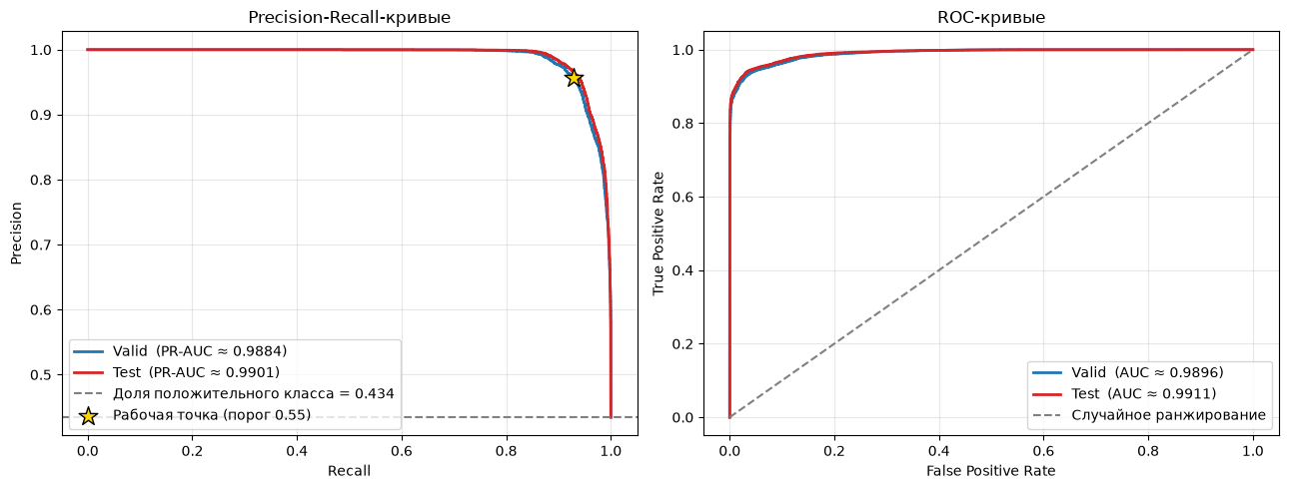
fig, ax = plt.subplots(figsize=(8, 4.5))
bins = np.linspace(0, 1, 50)
ax.hist(test_pd.loc[test_pd["label"] == 0.0, "score"], bins=bins, alpha=0.6, label="Not Satisfied", color="tab:blue")
ax.hist(test_pd.loc[test_pd["label"] == 1.0, "score"], bins=bins, alpha=0.6, label="Satisfied", color="tab:red")
ax.axvline(BEST_THRESHOLD, color="black", linestyle="--", label=f"Порог = {BEST_THRESHOLD:.2f}")
ax.set(xlabel="Score модели (вероятность Satisfied)", ylabel="Число пассажиров", title="Распределение score по классам на test")
ax.legend()
plt.tight_layout()
plt.savefig(OUT / "test_score_distribution.png", dpi=160)
plt.show()
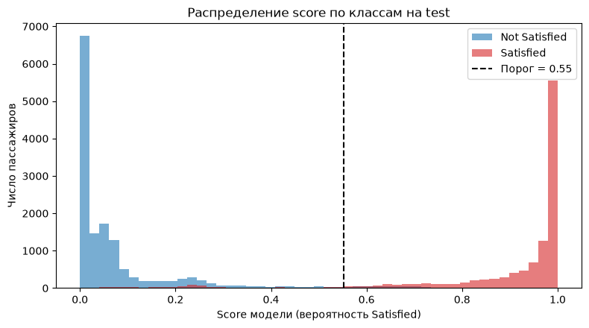
sample = best_model.transform(air_valid.limit(1))
meta = sample.schema["features"].metadata
attrs = meta.get("ml_attr", {}).get("attrs", {})
pairs = []
for kind in ("numeric", "nominal", "binary"):
for a in attrs.get(kind, []):
pairs.append((a["idx"], a["name"]))
pairs.sort()
feature_names_full = [name for _, name in pairs]
print(f"Найдено координат в метаданных: {len(feature_names_full)}")
rf_stage = best_model.stages[-1]
importances = rf_stage.featureImportances.toArray()
print(f"Длина вектора importances: {len(importances)}")
assert len(feature_names_full) == len(importances), "Рассинхрон имён и важностей"
order = np.argsort(importances)[::-1][:20]
fig, ax = plt.subplots(figsize=(9, 6.5))
ax.barh([feature_names_full[i] for i in order][::-1], importances[order][::-1], color="tab:green")
ax.set_xlabel("Важность координаты вектора")
ax.set_title("Топ-20 координат вектора признаков (RandomForest)")
plt.tight_layout()
plt.savefig(OUT / "test_feature_importance.png", dpi=160)
plt.show()
print("\nТоп-10 важных координат:")
for i in order[:10]:
print(f" {feature_names_full[i]}: {importances[i]:.4f}")
Найдено координат в метаданных: 33
Длина вектора importances: 33
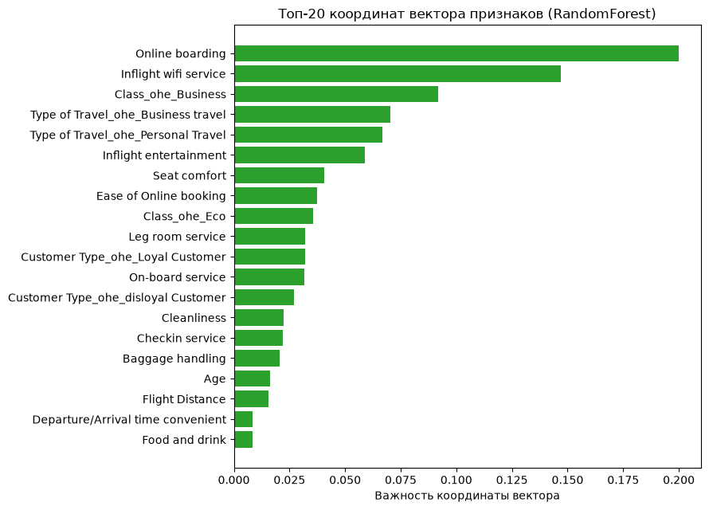
Топ-10 важных координат:
Online boarding: 0.2000
Inflight wifi service: 0.1471
Class_ohe_Business: 0.0919
Type of Travel_ohe_Business travel: 0.0704
Type of Travel_ohe_Personal Travel: 0.0668
Inflight entertainment: 0.0588
Seat comfort: 0.0405
Ease of Online booking: 0.0374
Class_ohe_Eco: 0.0357
Leg room service: 0.0322
thresholds_sweep = np.linspace(0.05, 0.95, 60)
metrics_sweep = []
for t in thresholds_sweep:
m = binary_metrics(test_scores, threshold=t, ranking=False)
metrics_sweep.append({"threshold": t, **m})
sweep_df = pd.DataFrame(metrics_sweep)
fig, ax = plt.subplots(figsize=(9, 5))
for col, color in [("precision", "tab:blue"),
("recall", "tab:red"),
("f1", "tab:green"),
("accuracy", "tab:purple")]:
ax.plot(sweep_df["threshold"], sweep_df[col], label=col, color=color, linewidth=2)
ax.axvline(BEST_THRESHOLD, linestyle="--", color="black", label=f"Выбранный порог = {BEST_THRESHOLD:.2f}")
ax.set(xlabel="Порог решения", ylabel="Метрика", title="Зависимость метрик от порога на test")
ax.grid(alpha=0.3)
ax.legend()
plt.tight_layout()
plt.savefig(OUT / "test_threshold_sweep.png", dpi=160)
plt.show()
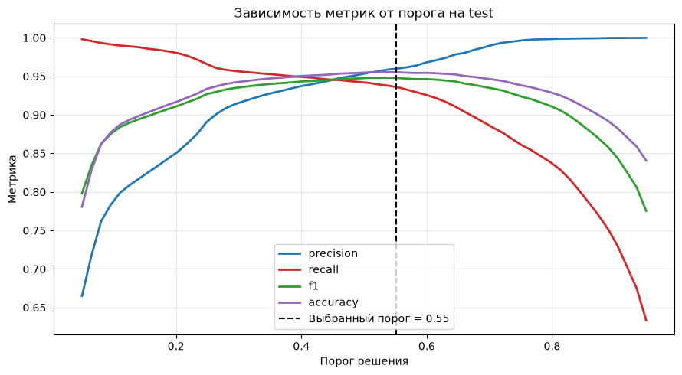
from pyspark.ml import PipelineModel
import json
best_model.write().overwrite().save((OUT / "airline_classifier").as_posix())
config = {
"seed": SEED,
"task": "binary_classification",
"dataset": "Airline Satisfaction Data",
"n_train": 77927,
"n_valid": 25976,
"n_test": 25977,
"best_model": best_name,
"threshold": round(BEST_THRESHOLD, 4),
"feature_count": len(feature_names_full),
"test_pr_auc": round(test_metrics["areaUnderPR"], 4),
"test_roc_auc": round(test_metrics["areaUnderROC"], 4),
"test_f1_at_threshold": round(test_metrics["f1"], 4),
"spark_version": spark.version,
}
(OUT / "airline_config.json").write_text(
json.dumps(config, ensure_ascii=False, indent=2), encoding="utf-8")
print(json.dumps(config, ensure_ascii=False, indent=2))
{
"seed": 42,
"task": "binary_classification",
"dataset": "Airline Satisfaction Data",
"n_train": 77927,
"n_valid": 25976,
"n_test": 25977,
"best_model": "RF(trees=100, depth=12)",
"threshold": 0.5515,
"feature_count": 33,
"test_pr_auc": 0.9901,
"test_roc_auc": 0.9911,
"test_f1_at_threshold": 0.9479,
"spark_version": "4.2.0"
}

Очистка и остановка
final_summary = {
"task": "Binary classification — airline passenger satisfaction",
"dataset": "Airline Satisfaction Data",
"n_rows_total": 129880,
"n_features": len(feature_names_full),
"split": {"train": 77927, "valid": 25976, "test": 25977},
"scenarios": {
"A_with_delay": "признак Departure Delay включён (основной)",
"B_without_delay": "задержка исключена (абляция)",
},
"baseline_constant": {
"accuracy": 0.5655,
"pr_auc": 0.4345,
},
"baseline_rule_by_class": {
"accuracy": 0.7507,
"precision": 0.6935,
"recall": 0.7639,
"f1": 0.7270,
"pr_auc": 0.6610,
},
"models_valid": val_table.to_dict(orient="records"),
"best_model": best_name,
"best_threshold": round(BEST_THRESHOLD, 4),
"test_metrics": {
"accuracy": round(test_metrics["accuracy"], 4),
"precision": round(test_metrics["precision"], 4),
"recall": round(test_metrics["recall"], 4),
"f1": round(test_metrics["f1"], 4),
"roc_auc": round(test_metrics["areaUnderROC"], 4),
"pr_auc": round(test_metrics["areaUnderPR"], 4),
"tp": test_metrics["tp"],
"fp": test_metrics["fp"],
"fn": test_metrics["fn"],
"tn": test_metrics["tn"],
},
"ablation_without_delay_pr_auc": round(binary_metrics(pred_no_delay)["areaUnderPR"], 4),
"top10_features": [
{"name": feature_names_full[i], "importance": float(importances[i])}
for i in order[:10]
],
"spark_version": spark.version,
}
(OUT / "part2_summary.json").write_text(
json.dumps(final_summary, ensure_ascii=False, indent=2), encoding="utf-8")
print(json.dumps(final_summary, ensure_ascii=False, indent=2))
print(f"\nСохранено в {OUT / 'part2_summary.json'}")
{
"task": "Binary classification — airline passenger satisfaction",
"dataset": "Airline Satisfaction Data",
"n_rows_total": 129880,
"n_features": 33,
"split": {
"train": 77927,
"valid": 25976,
"test": 25977
},
"scenarios": {
"A_with_delay": "признак Departure Delay включён (основной)",
"B_without_delay": "задержка исключена (абляция)"
},
"baseline_constant": {
"accuracy": 0.5655,
"pr_auc": 0.4345
},
"baseline_rule_by_class": {
"accuracy": 0.7507,
"precision": 0.6935,
"recall": 0.7639,
"f1": 0.727,
"pr_auc": 0.661
},
"models_valid": [
{
"model": "RF(trees=100, depth=12)",
"fit_s": 61.7,
"accuracy": 0.9499923005851555,
"precision": 0.9491769362238014,
"recall": 0.9349636718057771,
"f1": 0.942016694192742,
"tp": 10552,
"fp": 565,
"fn": 734,
"tn": 14125,
"areaUnderROC": 0.9895895949691944,
"areaUnderPR": 0.9883668660683421
},
{
"model": "RF(trees=50, depth=8)",
"fit_s": 16.0,
"accuracy": 0.9353634123806591,
"precision": 0.9324750157558297,
"recall": 0.917685628211944,
"f1": 0.9250212119858886,
"tp": 10357,
"fp": 750,
"fn": 929,
"tn": 13940,
"areaUnderROC": 0.9819249515686407,
"areaUnderPR": 0.9784846398550986
},
{
"model": "LR(reg=0.01)",
"fit_s": 18.8,
"accuracy": 0.8740760702186634,
"precision": 0.8694569927168803,
"recall": 0.8356370724791777,
"f1": 0.8522116296932183,
"tp": 9431,
"fp": 1416,
"fn": 1855,
"tn": 13274,
"areaUnderROC": 0.9274749422979512,
"areaUnderPR": 0.9305682175238317
},
{
"model": "LR(reg=0.1)",
"fit_s": 8.2,
"accuracy": 0.8687634739759779,
"precision": 0.8682561944834034,
"recall": 0.822789296473507,
"f1": 0.8449115144897866,
"tp": 9286,
"fp": 1409,
"fn": 2000,
"tn": 13281,
"areaUnderROC": 0.9231722386706084,
"areaUnderPR": 0.9264768643186833
},
{
"model": "Baseline: правило по Class",
"fit_s": 0.0,
"accuracy": 0.7507314444102248,
"precision": 0.693508165071193,
"recall": 0.763866737550948,
"f1": 0.7269890795631826,
"tp": 8621,
"fp": 3810,
"fn": 2665,
"tn": 10880,
"areaUnderROC": 0.7554567084143238,
"areaUnderPR": 0.6610488260311178
},
{
"model": "Baseline: константа",
"fit_s": 0.0,
"accuracy": 0.5655220203264552,
"precision": 0.0,
"recall": 0.0,
"f1": 0.0,
"tp": 0,
"fp": 0,
"fn": 11286,
"tn": 14690,
"areaUnderROC": 0.5,
"areaUnderPR": 0.4344779796735448
}
],
"best_model": "RF(trees=100, depth=12)",
"best_threshold": 0.5515,
"test_metrics": {
"accuracy": 0.9553,
"precision": 0.9599,
"recall": 0.9362,
"f1": 0.9479,
"roc_auc": 0.9911,
"pr_auc": 0.9901,
"tp": 10566,
"fp": 441,
"fn": 720,
"tn": 14250
},
"ablation_without_delay_pr_auc": 0.9882,
"top10_features": [
{
"name": "Online boarding",
"importance": 0.19998172501819494
},
{
"name": "Inflight wifi service",
"importance": 0.1470753430544692
},
{
"name": "Class_ohe_Business",
"importance": 0.0919066755266118
},
{
"name": "Type of Travel_ohe_Business travel",
"importance": 0.07044325727640816
},
{
"name": "Type of Travel_ohe_Personal Travel",
"importance": 0.06681643826617205
},
{
"name": "Inflight entertainment",
"importance": 0.058838519492901725
},
{
"name": "Seat comfort",
"importance": 0.040471345963328596
},
{
"name": "Ease of Online booking",
"importance": 0.03741015171176465
},
{
"name": "Class_ohe_Eco",
"importance": 0.0356970712395151
},
{
"name": "Leg room service",
"importance": 0.03215380253504666
}
],
"spark_version": "4.2.0"
}
Сохранено в C:\Additional\VirtualMachines\prac5\part2_results\part2_summary.json
cached_dfs = [
"air_split", "air_train", "air_valid", "air_test",
"baseline_constant", "baseline_class",
"test_scores", "best_pred_valid", "pred_no_delay",
]
for name in cached_dfs:
df = globals().get(name)
if df is not None and hasattr(df, "unpersist"):
try:
df.unpersist()
print(f"unpersist OK: {name}")
except Exception as e:
print(f"unpersist FAIL: {name}: {e}")
else:
print(f"skip: {name}")
unpersist OK: air_split
unpersist OK: air_train
unpersist OK: air_valid
unpersist OK: air_test
unpersist OK: baseline_constant
unpersist OK: baseline_class
unpersist OK: test_scores
unpersist OK: best_pred_valid
unpersist OK: pred_no_delay
print("Spark UI (работает до следующей строки):", sc.uiWebUrl)
spark.stop()
print("SparkSession остановлена. Работа завершена.")
Spark UI (работает до следующей строки): http://MSI:4040
SparkSession остановлена. Работа завершена.

